**Brooklyn torah gazette**

**For parshas va’era 5783**

Volume 7, Issue 19 (Whole Number 326) 28 Teves 5783/ January 21, 2023

**Printed L’illuy nishmas Nechama bas R’ Noach, a”h**

For a free subscription, please forward your request to [***keren18@juno.com***](mailto:keren18@juno.com)

Past stories can be found on the website **ShabbosStories.com**

**G-d, Are You There?**

**By Rabbi Nechemia Coopersmith**



***How to feel that G-d is an active part of your life.***

The first of the Ten Commandments is the mitzvah to know G-d exists. Maimonides, the towering 12th century codifier of Jewish law, opens his magnum opus, the Mishneh Torah, stating: “The foundation of all foundations and the pillar of all wisdom is *to know* that there is a Primary Being who brought all existence into being.”

In Hebrew the word “to know” has an additional, surprising meaning. In the Book of Genesis it says, “Adam knew his wife Eve, she conceived and gave birth to Cain” ([Genesis, 4:1](https://www.sefaria.org/Genesis.4.1?lang=he-en&utm_source=aish.com&utm_medium=sefaria_linker)). *Da’at,* knowledge, also means sexual intimacy, carnal knowledge.

Why should the same word be used for both? What’s the deeper connection between knowledge and intimacy?

You only truly know something when you internalize it and it becomes a part of you. That happens when what you know in your head trickles down and penetrates your heart.

**Bottom of Form**

Take a smoker, for example. He intellectually knows smoking is dangerous to his health and causes cancer, but he easily dismisses the facts. Upon visiting a cancer ward, he sees firsthand patients languishing from lung cancer and the reality hits him: smoking can kill you. What changed? He already knew all the facts.

Seeing the consequences in full living color makes it real and delivers a wallop. Only once it penetrates his heart does he truly know the consequences of smoking, even if an hour later the disconnect between mind and heart reemerges.

[The commandment to know that G-d exists](https://aish.com/48971891/) starts with the mind, our primary tool to perceive reality, but then it needs to enter the heart, the seat of your emotions. Without intimate knowledge, the existence of G-d remains an abstraction disconnected from one’s daily life, making it all too easy to ignore Him. The goal is to integrate what you know is true, to feel G-d’s reality in your bones and create a dynamic relationship, one that is grounded in thought but animated with love.



It’s a formidable challenge. Rabbi Eliyahu Dessler, a 20th century thinker, said that the distance between the mind and the heart is greater than the distance between the Earth and the moon.

How can you close the gap and assimilate your belief in G-d into the very fiber of your being?

I struggle with this (don’t we all?) but here are a few classic Jewish approaches that make a difference. (Obviously this is only relevant to those who already believe in G-d.)

**Divine Providence**

G-d isn’t up in the Heavens, divorced from the world, unaware and uninvolved. Since He is the omniscient and omnipotent Creator who sustains all life every instant, everything that happens is part of His Divine orchestration. Nothing is accidental; things happen for a reason. You may not always see how or why – after all, none of us have G-d’s “everything-everywhere-all-at-once” bird’s eye view, but you’ll be surprised by how often you can detect G-d’s active involvement in your life when you start looking for it.

Start with the big events in your life – the good and the bad. They’re not a coincidence. Peer behind the Divine providence and see if you can determine a message G-d is sending to you.

Sometimes it’s just a wink, a reminder that He’s got your back, like what happened to me a couple of months ago.

My wife went to pick up our 18-year-old son Yehuda, who has Down’s syndrome, at the pool. He was gone. The pool attendant said that Yehuda had left over an hour ago! It wasn’t the first time our fiercely independent and curious son wandered off, but this was the first time it happened outside our neighborhood and naturally, we were concerned.

**Found Him Eating Dinner Upstairs**

My wife couldn’t find him in the eateries at the nearby mall, so we called the police to aid us in the search. I stayed at home to man the phone and 90 minutes later my wife called to tell me that she had found him eating dinner upstairs in the mall. Chastened by the friendly police, they were on their way home.

I finally had two free minutes to tackle that day’s wordle (I’m hooked). I decided to go rogue and skip my go-to starting word, and asked, “Okay G-d, given what just happened with Yehuda, what would be a fitting word?”

I typed the word “FOUND” and bingo – got it on the first try! The odds of that happening are a fraction of one percent (Google it). Who said G-d doesn’t have a sense of humor? I laughed out loud as [I felt G-d’s embrace](https://aish.com/48894482/), reminding me He’s right there with me.

**Gratitude and Blessings**

Giving, reciprocating, and appreciating create a flourishing emotional bank account that forms the foundation of a loving relationship, whether it’s your marriage, or your relationship with G-d.

When a couple give to each other and express gratitude, taking nothing for granted, the strength of their love and trust for each other enables them to withstand the occasional rough patch that is a part of every marriage.

Your relationship with G-d works the same way. If you discount all the blessings God has given to you over your lifetime, and take for granted all the good that He showers upon you, is it any wonder you feel that He’s distant?

Count your blessings and put G-d into the picture; *He’s* the source of the abundant gifts you have in your life: your eyesight, hearing, your kids, your home, a cup of espresso….

Take stock and remind yourself that these didn’t just appear in your life. They are gifts you have received from a kind and super-involved G-d who has demonstrated His love for you time after time. With grateful eyes you can feel G-d’s unwavering love.

That’s why Jews are obsessed with gratitude and reciting blessings throughout the day. It’s literally the meaning of the word “Jew” – “*Yehudi*” in Hebrew – which means to admit and give thanks. Because that is the bedrock of a loving relationship.

So, if you want to feel that G-d is an active part of your life, open your eyes, appreciate all the blessings He has and continues to give you, and embrace His love.

*Reprinted from this week’s website of aish.com*

**Thoughts that Count**

*I appeared to Abraham, to Isaac and to Jacob (Ex. 6:3)*

One of the foremost Torah commentators, Rashi, adds the words "el ha'avot - to the forefathers," when explaining the above verse. It is well known that Abraham, Isaac and Jacob were the forefathers. What, then, does Rashi's comment add? The word "avot" is connected to the word "ava," which means "want."

Rashi is explaining that G-d said to Moses, "I appeared to Abraham, Isaac and Jacob because they wanted to have contact with me." Every Jew can have this kind of relationship with G-d, if he wants. *(Chatam Sofer)*

*Reprinted From Vedibarta Bam by Rabbi Moshe Bogomilsky*

**Rav Avigdor Miller on the**

**On-the-Derech Phenomenon**

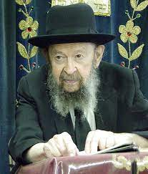

**QUESTION:** **Why do we have so many boys and girls going off the derech?**

**ANSWER:** First of all, let’s say the opposite. Why are there so many good children on the derech? I always say the same thing. I was once invited to speak to a gathering of frum girls, Bais Yaakov girls. Two thousand girls were sitting there. It was years ago – by this time they’re all married and all have children. Two thousand frum girls!

And later people told me it’s nothing, that there’s much more. There are two thousand girls in this place, a thousand there. Boruch Hashem! Boruch Hashem, we have many beautiful schools with children everywhere; everywhere today. So many thousands of people today are raising their children the right way. Here’s a frum girls’ school. Ten buses are lined up outside! I saw it! A long line of school buses! So. let’s concentrate on that.

Of course, it’s a pity if some of them chas v’shalom went off the derech; but first of all, let’s appreciate the tremendous metamorphosis, the tremendous mahapeichah. A revolution is taking place. The Am Yisroel is increasing and multiplying, and very, very many people are becoming frummer and frummer. Boruch Hashem! We rejoice in them! When you see frum Jews, give them a brachah. Hakodosh Boruch Hu wants them to increase and multiply. That’s His main desire, that the Am Yisrael should increase and multiply.

And so, yes, there are certain things that have to be done – now is not the place to talk about it – in order to make the schools more effective in training the boys and girls in yiras shamayim and how to live successfully. Some boys are not capable of learning Gemara. They need more mussar, more hashkafah. There are certain changes that have to be instituted. No, everything is not perfect; no.

Nevertheless, right now we should concentrate our minds and thank Hakodosh Boruch Hu on the great happiness we feel today when you see that the Jewish nation is increasing.

By the way, in Eretz Yisroel that’s the main worry of the reshaim. The reshaim are very much concerned. They see if they don’t do something extreme soon the frummer will take over everything. That’s what they’re worried about. They’re like Pharaoh; he said פן ירבה. So, Hashem says כן ירבה.

*Reprinted from the January 12, 2023 email of Toras Avigdor (Tape #E-246 – August 2000).*

**Reflections About the Imminent**

**Redemption of the Jewish People**

**From the Teachings of the Lubavitcher Rebbe**

**Rabbi Menachem Mendel Schneerson, Zt”l**

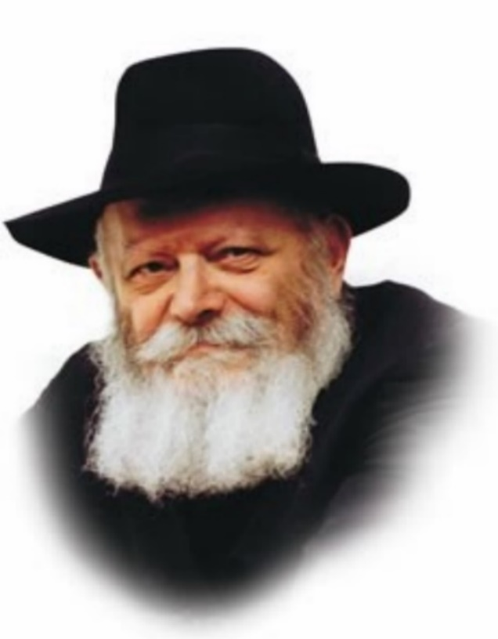

This week's Torah portion, Va'eira, contains the four expressions of redemption: "vehotzeiti -- and I will take you out," "vehitzalti -- and I will save you," "vega'alti -- and I will redeem you," "velakachti -- and I will bring you."

Each one of these terms refers to a different historical exile, of which there have been four. (Our present exile, the fourth, is the final exile after which there will be no others.) "And I will take you out" refers to the Jewish people's redemption from Egypt, and so on with each of the above phrases.

Va'eira contains an additional expression, "veheiveiti -- and I will bring you to the good land." This fifth term of redemption alludes to the Final Redemption with Moshiach.

In this week's Torah portion G-d promises to bring us the ultimate Redemption. Whenever G-d promises to do something good, He never reconsiders his decision or regrets it. G-d has willed that a good thing can never be nullified. His promise to redeem us can therefore never be abrogated, G-d forbid. It is axiomatic that the Holy One, Blessed Be He, must fulfill His promise to bring Moshiach.

According to halacha (Jewish law), if a person sets a fire and the fire spreads, the one who set it is responsible for any damage it causes. Even if he did not intend for the fire to spread in that direction, he is obligated to reimburse anyone who incurs a loss. The very act of lighting the fire causes him to assume responsibility, even before any damage has occurred.

**Redemption Exists Even Now**

If halacha mandates this level of responsibility when it comes to loss or injury, how much more so does this hold true when it comes to good! Consequently, the full and complete Redemption is already in existence, even before it has completely come about. The Redemption exists even now; all that is necessary is that it be revealed to us.

Recognizing that the Redemption already exists, and that all that is missing is the stage of revelation, makes it easier for us to contend with the exile's difficulties and overcome its trials and tribulations, especially in recent generations.

We must never allow ourselves to be overpowered by the exile. Rather, we must continue to act with the power of holiness, which will cause all of the exile's concealments and difficulties to disappear. In this manner we will merit to see the Redemption with eyes of flesh, speedily in our day.

*Reprinted from the Parshat Vayechi 5783 edition of L’Chaim (Issue #503) Adapted from Likutei Sichot, Volume 1.*

**Rabbi Berel Wein on**

**Parshas Vaeira 5783**



As the narrative of the redemption of the Jewish people from Egyptian bondage unfolds, I am continually struck by the apparently gradual process that is described for us in the Torah. What does all of the detail associated with each of the plagues visited upon Egypt come to teach us? And would not one great plague alone have sufficed? After all, in the past century we witnessed how two bombs, alone, forced the powerful and fanatical Japanese Empire to surrender unconditionally. So, what is the message of the ten plagues and the elapse of time from the onset of the mission of Moshe to its final successful conclusion?

These issues are raised and discussed by all of the great rabbinic commentators over the ages. As is usual in Jewish biblical commentary, there is no one definitive answer, for the Torah itself is said to have seventy different “faces.”  Yet, there is much ground for a general understanding of the matter in their writings and opinions.

The main thrust of rabbinic opinion is that all of this was necessary to give the Egyptians an opportunity to repent and save themselves and, just as importantly, to give the Jews an opportunity to begin to think of themselves as a free and independent people and no longer as slaves and pagans. It takes time and a series of many events to turn around the mentality and preconceived ideas of human beings.

The Egyptians had to somehow become accustomed to the fact that they had no right to rule over others and be cruel to their fellow human beings. The Jews had to become accustomed to the responsibilities of freedom and an independent life and to realize that they were destined to be a special people dedicated to the service of G-d and humankind.

These things cannot happen suddenly and if they do, then they are not of a long-lasting nature. Judaism is not built upon sudden epiphanies but rather upon the long, grinding routine. Only after ten plagues have visited Egypt, the Egyptians and the Jews as well begin to understand what G-d wants from them.

We see from many incidents recorded for us throughout the Bible that one-shot-miracles, no matter how impressive and meaningful they are at the moment they occur, do not really change the mindset of people in the long run. The miracle performed through Elijah, when all of Israel proclaimed that Hashem is the G-d of the universe, was not of a long-lasting nature and/or influence.

The people soon sank back into the swamp of idolatry and immorality. Regularity, consistency and repeated instruction and education are necessary to make miracles truly influential and long-lasting. If the Jews had been delivered from Egyptian bondage by one great miracle, they would have had a much harder time grasping the unique role that G-d intended them to play in world history.

They would have been much more reticent to accept that role at Sinai had it not been for the fact that they witnessed so many miracles. Those miracles were repeated regularly and explained to them by Moshe in the light of the godly Torah, which they now willingly accepted.

Shabbat shalom

*Reprinted from this week’s website of rabbiwein.com*

**More Thoughts that Count**

*These are the heads of their father's houses (Ex. 6:14)*

The Torah traces the genealogy of Moses and Aharon to emphasize that a Jewish leader is not one born in a supernatural way. He is a person with a mother and father who has spiritually elevated himself to be worthy of his rank. *(Ma'ayana Shel Torah)*

*These are the names of the children of Levi: Gershon and Kehat and Merari (Ex. 6:16)*

The children of all of the Twelve Tribes were enslaved except for the children of Levi. Levi felt that his children should participate in some way and remember the suffering of their brethren, so he named them in a way which would remind them of their exile.

Gershon is connected with the word "ger," meaning "stranger," for the Jews were strangers in a land not their own.

Kehat comes from the word "dull"; the Jews' teeth were dulled by their difficulties.

The name Merari comes from "mar" which means "bitter," for their lives were made bitter by the Egyptian exile. *(Shaloh)*

*Aaron threw his staff in front of Pharoah and his servants, and it became a snake. (Ex. 7:10)*

Pharoah claimed that the Jews had sinned and that they did not deserve to be taken out of Egypt. Moshe and Aaron responded that a person's environment plays a very important role in his development. Even a holy staff can turn to a vicious snake in the company of Pharoah. On the other hand, a "snake" in the company of Moses and Aaron can transform itself into a holy staff. *(Rabbi Meir Shapiro of Lublin)*

*Reprinted From Vedibarta Bam by Rabbi Moshe Bogomilsky*

**No Toy Prizes**

**Please, Just Cash**

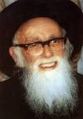

Over 100 years ago, R’ Chaim Goldfarb served as a rebbi in the Eitz Chaim Yeshiva in Yerushalayim. He inspired his talmidim to aspire to learn more and learn better, by offering incentives and prizes. These were especially appreciated by his talmidim, most of whom were poverty stricken, and had nothing more than bare necessities.

It was a major treat to receive little pieces of chocolate and small prizes. The class consisted of numerous bright boys who excelled in learning. But there was one child who stood out even amongst these outstanding talmidim – his name was Shlomo. He mastered every word of Torah that he learned, and when he was seven years old, he was already regarded as a budding talmid chochom, destined for greatness.

But there was something about Shlomo that troubled the Rebbi. Shlomo was only interested in one prize – money. It seemed so out of character for him, as he was not raised to attribute too much significance to money. The Rebbi thought about speaking with Shlomo about his preference for money, but he decided to put the matter on hold and wait.

A few weeks passed, and Shlomo received another prize for his outstanding achievements in learning. Shlomo requested money instead of the prize. The Rebbi graciously exchanged the prize for a few coins. Curious about what he would do with the money, the Rebbi followed Shlomo.

Instead of going home, Shlomo turned into a store. What toy would he buy? What better seforim did he want to buy? Shlomo emerged, saw his rebbi, and tried to hide what was in his hand.

The Rebbi, seeing what seemed to be a toy or gadget in Shlomo’s hand, looked disappointed. “Were my prizes not good enough? What did you feel you had to buy that is better?”

Shlomo looked down, and left with no choice, had to explain. “My mother does not hear well, and she expressed a desire for a new hearing aid. So, I decided that if I saved enough money from my prizes, I could buy her a new one.”

With tears in his eyes, the Rebbi enveloped Shlomo with a hug, and apologized profusely for having misjudged him. Little Shlomo grew up to become the Torah giant of his generation, R’ Shlomo Zalman Auerbach, renowned not only for his Torah genius and psak halacha, but his keen sensitivity and caring for others. (Stories to Inspire)

*Reprinted from the Parshas Va’eira 5783 email of The Weekly Vort.*

**In a Gentle Manner**

**By Rabbi Yitzchok Zilberstein**

*G-d spoke to Moshe and said to him, “I am Hashem” (6:2).*

The term “vayedabeir” connotes harsh speech, as indicated by the verse, The man, the lord of the land, spoke (dibeir) harshly to us (Bereishis 42:30). The term “vayomer” represents gentle speech, as indicated by the verse, So shall you say (somar) to the House of Yaakov (19:3), on which Rashi comments, “Say to the women, with gentle language.”

In the verse, “G-d spoke (vayedaber) to Moshe and said (vayomer) to him, ‘I am Hashem,’” we find both types of speech.

“G-d spoke” represents harsh speech, while “and said” represents gentle speech. Which one was it? Did Hashem speak harshly or gently? The answer is: Both. Hashem was reprimanding Moshe, as Rashi says, “He spoke to Moshe with words of rebuke for speaking harshly and saying, ‘Why have you harmed this people?’”

But the Torah is teaching us that even when rebuke is necessary, it should be given in a gentle manner. This concept is also expressed in the verse, Then Yaakov became angered and he took up his grievance with Lavan; Yaakov spoke up and said to Lavan (Bereishis 31:36). Although the Torah states clearly that Yaakov “took up his grievance with Lavan,” the Torah uses the term “vayomer” — Yaakov spoke gently.

The Chofetz Chaim points out that even though Yaakov was angered, he did not speak harshly, in anger, but rather addressed Lavan in a gentle tone.

Shlomo Hamelech tells us: Do not rebuke a scoffer, lest he hate you; rebuke a wise man, and he will love you (Mishlei 9:8). We learn from this verse that when rebuking a person, we should not tell him, “You’re a scoffer.” Rather, we should tell him, “You’re a wise man!” — and it is therefore unbecoming for you to act in a certain way.

The chances of success in influencing a person to change his ways are much greater if we speak to him in this way than if we pour harsh criticism upon him. This is the task of our generation. Many people who are distant from Torah are interested in hearing about our lifestyle, but we have to speak to them gently.

This requires special skill, and it is our duty to learn this skill. The gentle speech that we need to use when speaking to our not yet-religious brethren is particularly important when we are trying to persuade them to observe mitzvos and bask in the light of Torah. When people see the fine middos that characterize Torah-observant people, they will be spurred to draw closer to us.

*Reprinted from the Parshas Va’eira 5782 email At the ArtScroll Shabbos Table. Excerpted from the ArtScroll book – Aleinu L’Shab’ei’ach.*

**Is Moses a Jewish**

**or Egyptian Name?**

**By**[**Yehuda Shurpin**](https://www.chabad.org/search/keyword_cdo/kid/15169/jewish/Shurpin-Yehuda.htm)

The Torah recounts how, three months after Moses was born, his mother tucked him into a basket, which she placed in the marsh at the river’s edge. Later, Pharaoh’s daughter went down to bathe and saw a basket among the reeds. She saved Moses and, in a fascinating turn of events, gave him to the child’s own mother to nurse him. The verse then states: “The child grew up, and she brought him to Pharaoh's daughter, and he became like her son. She named him Moses (Moshe), and she said, ‘For I drew him (*mishitihu*) from the water.’ ”

The obvious question is, is the name “Moses” Hebrew or Egyptian? At first glance, the verse seems to be using a Hebrew etymology, implying that it is a Hebrew name. But how would Pharaoh's daughter Bithiah even know Hebrew, let alone give the child a distinctly Hebrew name?

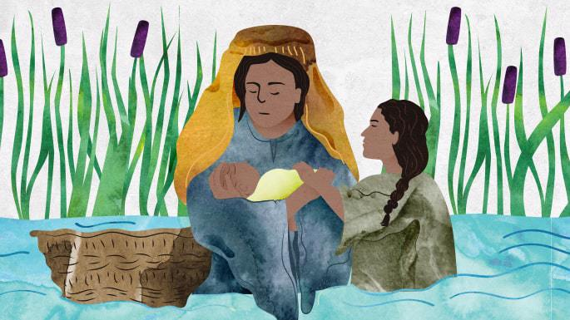

**The Name Is Hebrew**

One opinion is that it was indeed a Hebrew name. Bithiah had learned the Hebrew language from the Israelites who had settled in Egypt.[1](javascript:doFootnote('1a5753263');)

In a similar vein, the Talmud explains that Bithiah was going down to the river in order to immerse, cleanse herself of the idolatry in her father’s house, and adopt the Jewish faith. The commentaries explain that Bithiah indeed learned Hebrew, and when the time came, she named her adopted son the Hebrew name “Moses.”[2](javascript:doFootnote('2a5753263');)

Others[3](javascript:doFootnote('3a5753263');) maintain that it was actually Yocheved, Moses' mother, who called him that when she returned him to Bithiah, and Bithiah was agreeable to that name. Thus, the verse would read: “The child grew up, and she [Yocheved] brought him to Pharaoh's daughter, and he became like her son. She [Yocheved] named him Moses, and she said, ‘For I drew him from the water.’"

**Additional Egyptian Meaning**

The name “Moshe” is a conjunction of two Egyptian words: *mo*, which means “water,” and *uses*(or *sha*), which means “saved” or “drawn” from. Thus, Rabbi Meir Leibush Wisser, the Malbim, explains that the name “Moshe” actually has a similar connotation in both Egyptian and Hebrew.[4](javascript:doFootnote('4a5753263');)

**Hebrew Translation of Egyptian Name**

Some suggest that Bithiah named Moses with an Egyptian name that has been lost to us. The name “Moses” is actually Scripture’s Hebrew translation of the original Egyptian name.[5](javascript:doFootnote('5a5753263');)

**Saving a Life**

The Midrash relates that Moses actually had ten different names given variously by his parents, his tribe and the Jewish people (see [What Was Moses’ Name?](https://www.chabad.org/parshah/article_cdo/aid/627663/jewish/What-Was-Moshes-Real-Name.htm)). Nevertheless, it is very telling that the name he is known by is Moses, harking back to the heroic act of Bithiah, who put herself at risk to save a helpless child of a foreign nation. It was ultimately this selfless act that eventually brought about the salvation of the entire Jewish nation.

**FOOTNOTES**

[1.](https://www.chabad.org/library/article_cdo/aid/5753263/jewish/Is-Moses-a-Jewish-or-Egyptian-Name.htm" \l "footnoteRef1a5753263) *Daat Zekenim, Baalei Hatosafot*, on [Exodus 2:3](https://www.chabad.org/9863#v3).

[2.](https://www.chabad.org/library/article_cdo/aid/5753263/jewish/Is-Moses-a-Jewish-or-Egyptian-Name.htm" \l "footnoteRef2a5753263) *Chizkuni,*ad loc.

[3.](https://www.chabad.org/library/article_cdo/aid/5753263/jewish/Is-Moses-a-Jewish-or-Egyptian-Name.htm" \l "footnoteRef3a5753263) See *Chizkuni*(second explanation), *Abarbanel,*ad loc.

[4.](https://www.chabad.org/library/article_cdo/aid/5753263/jewish/Is-Moses-a-Jewish-or-Egyptian-Name.htm" \l "footnoteRef4a5753263) *Malbim* (citing Philo and Josephus).

[5.](https://www.chabad.org/library/article_cdo/aid/5753263/jewish/Is-Moses-a-Jewish-or-Egyptian-Name.htm" \l "footnoteRef5a5753263) *Ibn Ezra*and *Daat Zekenim, Baalei Hatosafot*, on [Exodus 2:3](https://www.chabad.org/9863#v3).

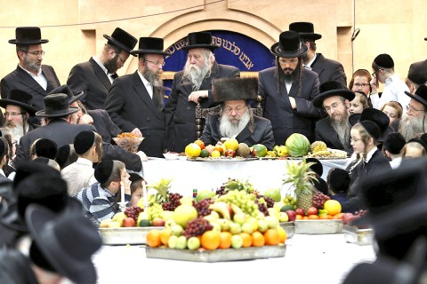

***Tu Bi’Shevat, the New Year of the Trees will be celebrated this year on Monday, February 6th. Jews observe this holiday be eating varied fruits.***